Given an m x n integers matrix, return *the length of the longest increasing path in* matrix.

From each cell, you can either move in four directions: left, right, up, or down. You **may not** move **diagonally** or move **outside the boundary** (i.e., wrap-around is not allowed).

**Example 1:**

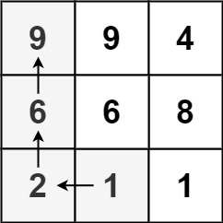

Input: matrix = [[9,9,4],[6,6,8],[2,1,1]]  
Output: 4  
Explanation: The longest increasing path is [1, 2, 6, 9].

**Example 2:**

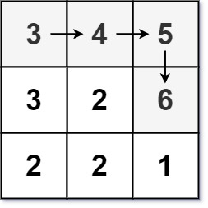

Input: matrix = [[3,4,5],[3,2,6],[2,2,1]]  
Output: 4  
Explanation: The longest increasing path is [3, 4, 5, 6]. Moving diagonally is not allowed.

**Example 3:**

Input: matrix = [[1]]  
Output: 1

**Constraints:**

* m == matrix.length
* n == matrix[i].length
* 1 <= m, n <= 200
* 0 <= matrix[i][j] <= 231 - 1